Once you have created views on different sheets in Tableau, you can pull them into a dashboard.

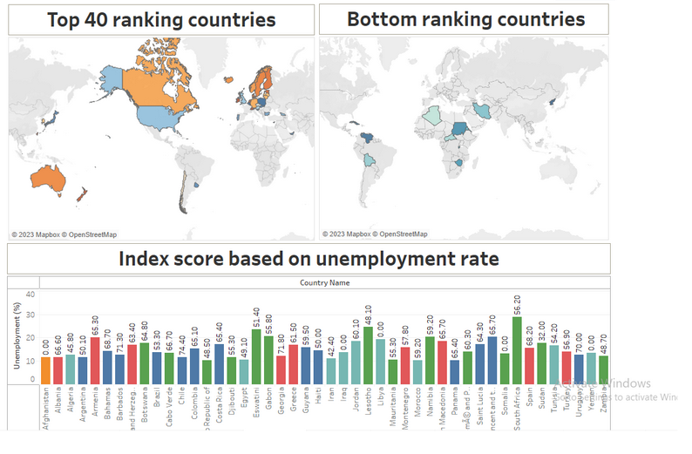
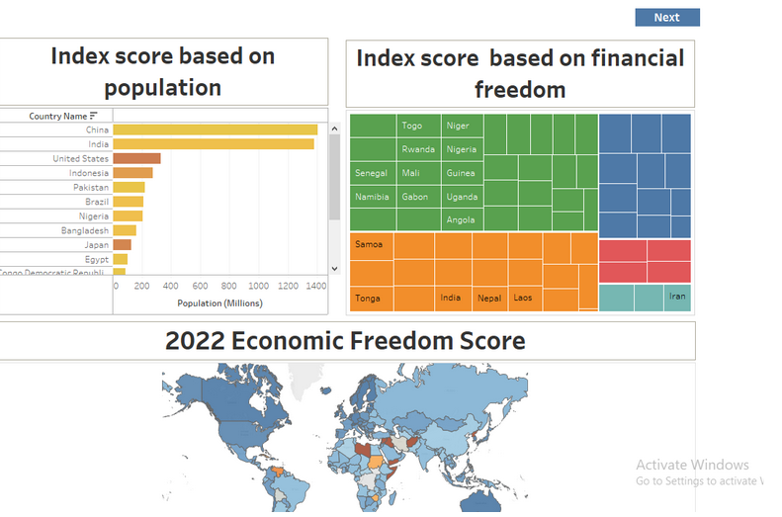

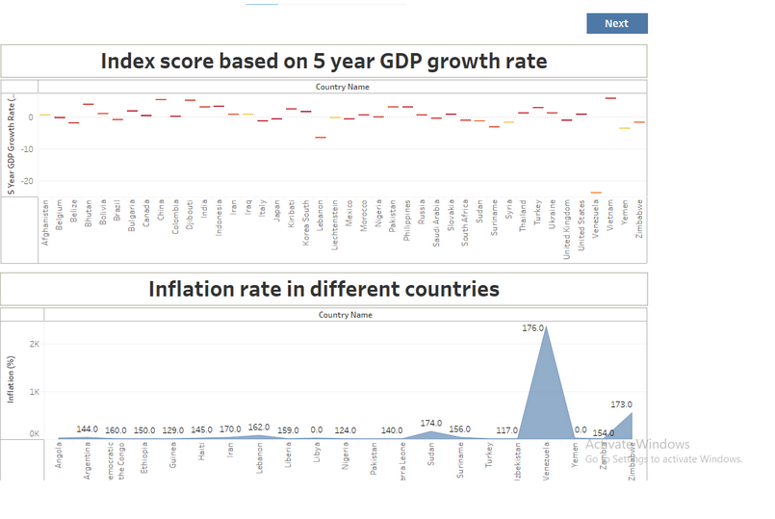

Story
A data story is a way of presenting data and analysis in a narrative format, with the goal of making the information more engaging and easier to understand. A data story typically includes a clear introduction that sets the stage and explains the context for the data, a body that presents the data and analysis in a logical and systematic way, and a conclusion that summarizes the key findings and highlights their
Creating the story board
Explanation video link: link

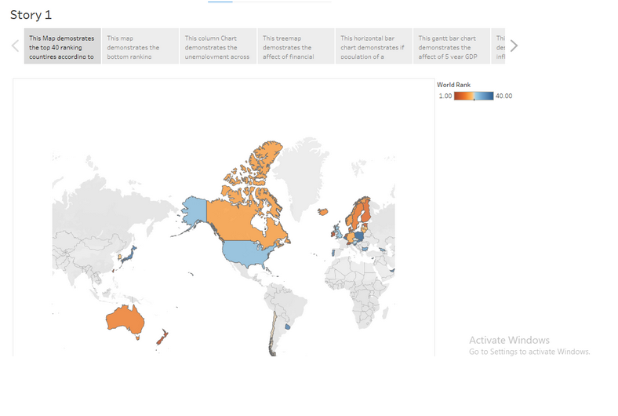
Publishing and Web integration
Publishing helps us to track and monitor key performance metrics, to communicate results and progress. help a publisher stay informed, make better decisions, and communicate their performance to others.
Explanation video link: link
Publishing dashboard and reports to tableau public
Step 1: Go to Dashboard/story, click on share button on the top ribbon
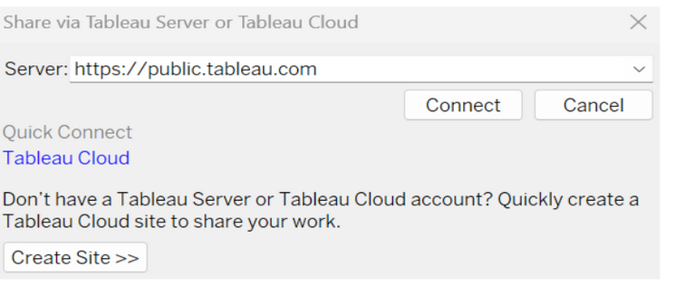
Give the server address of your tableau public account and click on connect.
Step 2: Once you click on connect it will ask you for tableau public user name and password

Once you login into your tableau public using the credentials, the particular visualization will be published into tableau public
Note: While publishing the visualization to the public, the respective sheet will get published when you click on share option.

Integrating with Web with Embed code
Explanation video link: link

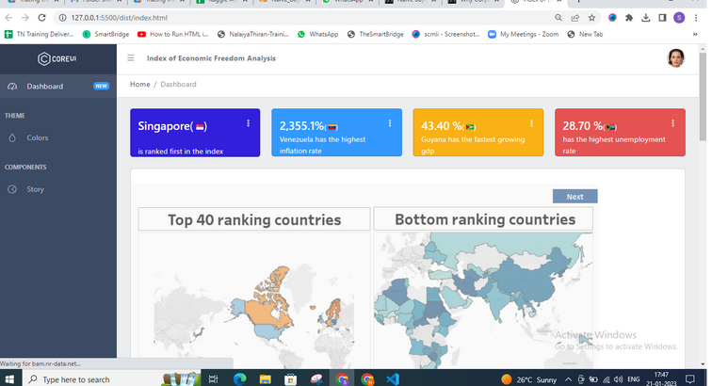

Performance Testing
Performance testing in Tableau helps ensure dashboards and reports load quickly and run efficiently, even with large data volumes or complex visualizations.
Amount of Data Rendered to DB
The amount of data that is rendered to a database depends on the size of the dataset and the capacity of the database to store and retrieve data.

Open the MySQL Workbench, go to the database then click to expand the tables,select the table and click on (i) button to get the information related to table such as column count,table rows etc.

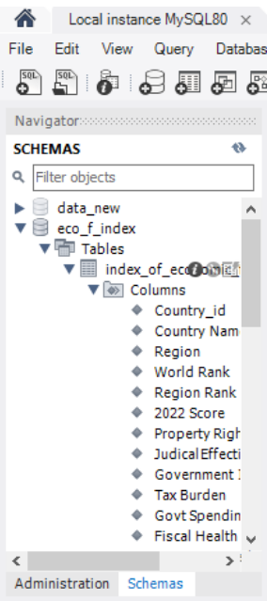

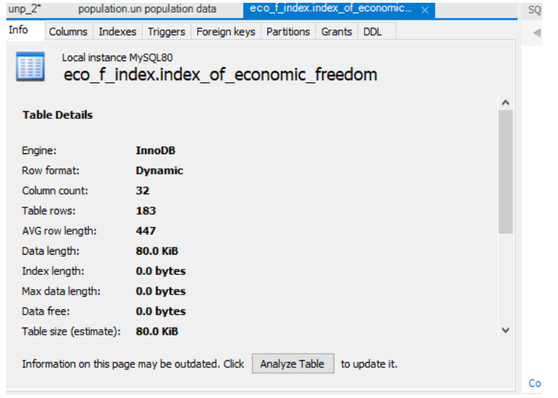
Utilization of Data Filters
